

# PO1_DGC Calculator

**(GDD)**

**Status**: **Draft**

### **Document Status**

|  |  |  |  |
| --- | --- | --- | --- |
| **Version** | **Status** | **Author** | **Date** |
| 1.0 | Draft | May Abdelsalam | 26/2/2020 |
| 1.0 | Draft | Moamen Ahmed | 27/2/2020 |
| 1.0 | Draft | May Abdelsalam | 27/2/2020 |
| 1.0 | Draft | Areej Ayman Helal | 27/2/2020 |
| 1.0 | Draft | Bishoy Nabil | 27/2/2020 |
| 1.1 | Proposed | Moamen Ahmed | 2/3/2020 |
| 1.2 | Proposed | May Abdelsalam | 2/3/2020 |
| 1.3 | Proposed | Moamen Ahmed | 4/3/2020 |
| 1.4 | Proposed | Moamen Ahmed | 6/3/2020 |
| 1.5 | Proposed | Moamen Ahmed | 13/3/2020 |

**History Table**

|  |  |  |  |
| --- | --- | --- | --- |
| **Version** | **Author** | **Date** | **Change** |
| 1.0 | May Abdelelsalam | 26/2/2020 | Initial creation |
| 1.0 | Moamen Ahmed | 27/2/2020 | Added HAL APIs |
| 1.0 | May Abdelelsalam | 27/2/2020 | Update on Input Output signals, Static Architecture |
| 1.0 | Areej Ayman Helal | 27/2/2020 | Added App APIs. |
| 1.0 | Bishoy Nabil | 27/2/2020 | Added MCAL APIs |
| 1.1 | Moamen Ahmed | 2/3/2020 | Added covers section to all requirements |
| 1.2 | May Abdelelsalam | 2/3/2020 | Added Input Output signals section and Software Features section |
| 1.3 | Moamen Ahmed | 2/3/2020 | Added new APIs and updated Covers section |
| 1.4 | Moamen Ahmed | 6/3/2020 | Minor changes to Req_PO1_DGC_GDD_006 |
| 1.5 | Moamen Ahmed | 13/3/2020 | Added Component section to each GDD requirement |

**Reference documents**

|  |  |  |  |
| --- | --- | --- | --- |
| **Reference number** | **Document name** | **Version** | **Status** |
| 1 | PO1_DGC Calculator  (SRS) | V1.7 | Proposed |

## Table of contents

1. Project Description.
2. Input Output signals.
3. Software features.
4. Static Architecture.
5. APP Components APIs.
6. HAL Components APIs.
7. MCAL Components APIs.

## Project Description

The Digital Calculator system will consist of a Power component in the APP layer to turn all the system ON whenever the ON switch is pressed.

The system starts with the Keypad_assignment component waiting for any of the Keypad keys to get pressed. When a switch of the keypad is pressed the Keypad_assignment component will send signals to all of the following components:

1- Math_calc: will calculate the entered operation and send the result to the Display component.

2- Display: will display the entered first operand, operation and second operand.

3- PlayTone: will play a tune every time keypad_assignment component is used.

## Software context diagram:

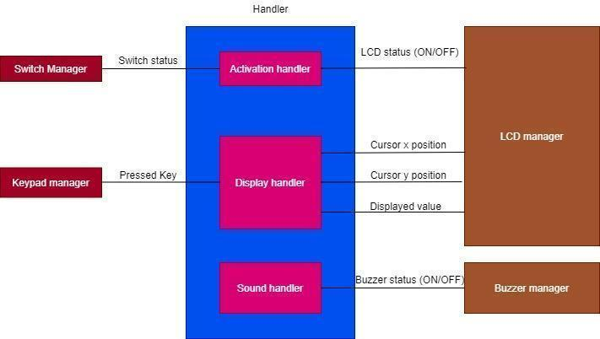

**Input Output signals:**

Input signals:

* Switch status.

Range: [0: 1]

Unit: NA

* Pressed Key:

Range: [0: 15]

Unit: NA

Output signals:

* LCD Status.

Range: [0: 1]

Unit: NA

* Curser X Position:

Range: [0: 15]

Unit: NA

* Curser Y Position:

Range: [0: 1]

Unit: NA

* Displayed value:

Range: [0: 9, +, -, *, /, =]

Unit: NA

* Buzzer Status.

Range: [0: 1]

Unit: NA

**Software features:**

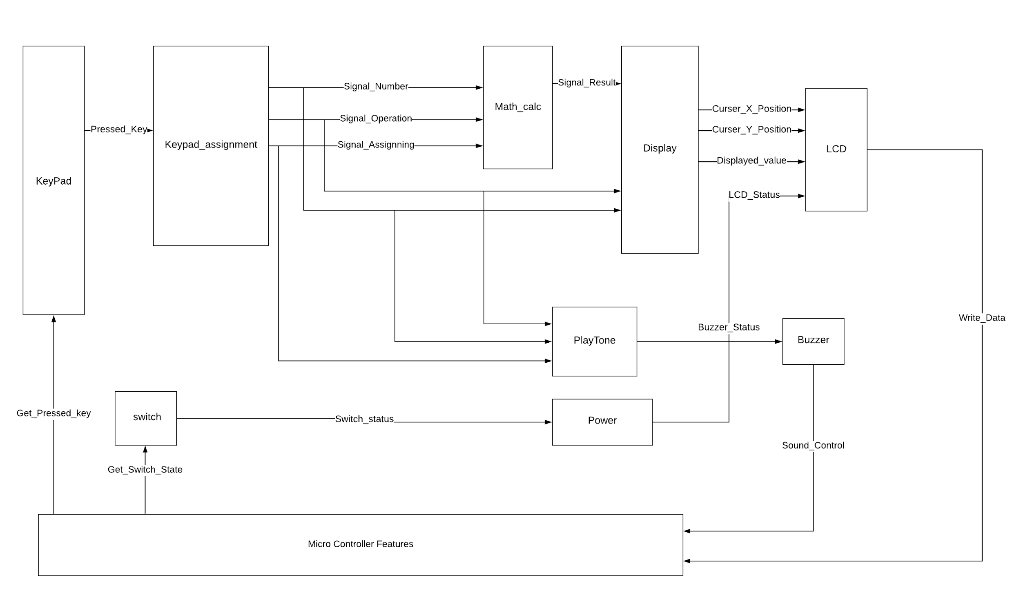

**Static Architecture:**

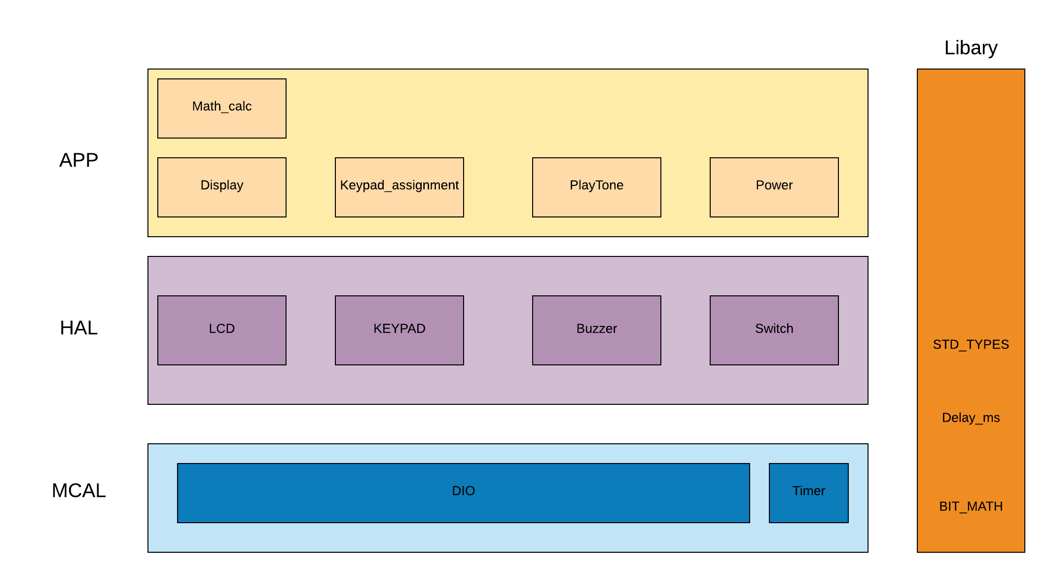

### **APP Components APIs:**

|  |  |  |  |
| --- | --- | --- | --- |
| **Req_ID** | Req_PO1_DGC_GDD_001 V1.4 | | |
| **Component** | Keypad_assignment | | |
| **Return Type** | STD_ERR | **Input arguments** | u8 Copy_u8PressedKey  u8* Copy_u8CalculatorKey |
| **Name** | DGC_KeypadAssignment | | |
| **Description** | It takes the pressed key as an input (1:16) and returns the corresponding number | | |
| **Covers** | Req_PO1_DGC_SRS_001_v1.3 | | |
| **Range** | Copy_u8PressedKey : (1:16)  Copy_u8CalculatorKey: (0:9,+,-,*,/,=)  return : OK, NOT_OK | | |

|  |  |  |  |
| --- | --- | --- | --- |
| **Req_ID** | Req_PO1_DGC_GDD_002 V1.4 | | |
| **Component** | Math_calc | | |
| **Return Type** | STD_ERR | **Input arguments** | f32* Copy_f32Result |
| **Name** | DGC_GetResult | | |
| **Description** | Returns the result of the operation. | | |
| **Covers** | Req_PO1_DGC_SRS_015_v1.3  Req_PO1_DGC_SRS_016_v1.3  Req_PO1_DGC_SRS_017_v1.3 | | |
| **Range** | Copy_f32Result (float range)  return : (OK, NOT_OK) | | |

|  |  |  |  |
| --- | --- | --- | --- |
| **Req_ID** | Req_PO1_DGC_GDD_003 V1.0 | | |
| **Component** | Math_calc | | |
| **Return Type** | STD_ERR | **Input arguments** | u8 Copy_u8Operand |
| **Name** | DGC_AssignOperands | | |
| **Description** | Assigns the input as first/second operand or operation. | | |
| **Covers** | Req_PO1_DGC_SRS_003_v1.3  Req_PO1_DGC_SRS_005_v1.3  Req_PO1_DGC_SRS_007_v1.3  Req_PO1_DGC_SRS_008_v1.3  Req_PO1_DGC_SRS_013_v1.3  Req_PO1_DGC_SRS_014_v1.3  Req_PO1_DGC_SRS_016_v1.3  Req_PO1_DGC_SRS_018_v1.3  Req_PO1_DGC_SRS_019_v1.3 | | |
| **Range** | Copy_u8Operand (0:9,+,-,*,/)  return : (OK, NOT_OK) | | |

|  |  |  |  |
| --- | --- | --- | --- |
| **Req_ID** | Req_PO1_DGC_GDD_004 V1.4 | | |
| **Component** | Display | | |
| **Return Type** | STD_ERR | **Input arguments** | u8 Copy_u8Char |
| **Name** | DGC_DisplayChar | | |
| **Description** | Display a single character on the LCD | | |
| **Covers** | Req_PO1_DGC_SRS_002_v1.3  Req_PO1_DGC_SRS_004_v1.3  Req_PO1_DGC_SRS_006_v1.3  Req_PO1_DGC_SRS_009_v1.3  Req_PO1_DGC_SRS_010_v1.3 | | |
| **Range** | Copy_u8Char: (0:9,+,-,*,/)  return : (OK, NOT_OK) | | |

|  |  |  |  |
| --- | --- | --- | --- |
| **Req_ID** | Req_PO1_DGC_GDD_005 V1.4 | | |
| **Component** | Display | | |
| **Return Type** | STD_ERR | **Input Arguments** | f32 Copy_f32Number |
| **Name** | DGC_DisplayNumber | | |
| **Description** | Display a base 10 number on the LCD. | | |
| **Covers** | Req_PO1_DGC_SRS_016_v1.3  Req_PO1_DGC_SRS_017_v1.3 | | |
| **Range** | Copy_f32Number (float range)  return : (OK, NOT_OK) | | |

|  |  |  |  |
| --- | --- | --- | --- |
| **Req_ID** | Req_PO1_DGC_GDD_006 V1.4 | | |
| **Component** | PlayTone | | |
| **Return Type** | STD_ERR | **Input arguments** | void |
| **Name** | DGC_PlayTone | | |
| **Description** | Plays a tone whenever a key is press on the keypad | | |
| **Covers** | Req_PO1_DGC_SRS_011_v1.3  Req_PO1_DGC_SRS_012_v1.3 | | |
| **Range** | return : (OK, NOT_OK) | | |

|  |  |  |  |
| --- | --- | --- | --- |
| **Req_ID** | Req_PO1_DGC_GDD_007 V1.3 | | |
| **Component** | Power | | |
| **Return Type** | STD_ERR | **Input arguments** | u8 Copy_u8PState |
| **Name** | DGC_Power | | |
| **Description** | It turns the system on or off whether it's from the power button or if the system idles for 15 seconds . | | |
| **Covers** | Req_PO1_DGC_SRS_020_v1.3 | | |
| **Range** | Copy_u8PState: (0,1)  return : (OK, NOT_OK) | | |

### **HAL Components APIs**

|  |  |  |  |
| --- | --- | --- | --- |
| **Req_ID** | Req_PO1_DGC_GDD_008 V1.1 | | |
| **Component** | LCD | | |
| **Return Type** | STD_ERR | **Input arguments** | void |
| **Name** | LCD_Init | | |
| **Description** | Initialize LCD with determined configurations | | |
| **Covers** | - | | |
| **Range** | return : (OK, NOT_OK) | | |

|  |  |  |  |
| --- | --- | --- | --- |
| **Req_ID** | Req_PO1_DGC_GDD_009 V1.1 | | |
| **Component** | LCD | | |
| **Return Type** | STD_ERR | **Input arguments** | u8 Copy_u8Command |
| **Name** | LCD_WriteCommand | | |
| **Description** | Control the LCD using the commands found in the LCD datasheet | | |
| **Covers** | - | | |
| **Range** | Copy_u8Command: (0-255)  return : (OK, NOT_OK) | | |

|  |  |  |  |
| --- | --- | --- | --- |
| **Req_ID** | Req_PO1_DGC_GDD_010 V1.1 | | |
| **Component** | LCD | | |
| **Return Type** | STD_ERR | **Input arguments** | u8 Copy_u8Data |
| **Name** | LCD_WriteData | | |
| **Description** | Write a single character to the LCD | | |
| **Covers** | Req_PO1_DGC_SRS_002_v1.3  Req_PO1_DGC_SRS_004_v1.3  Req_PO1_DGC_SRS_006_v1.3  Req_PO1_DGC_SRS_009_v1.3  Req_PO1_DGC_SRS_010_v1.3 | | |
| **Range** | Copy_u8Data: (0-255)  return : (OK, NOT_OK) | | |

|  |  |  |  |
| --- | --- | --- | --- |
| **Req_ID** | Req_PO1_DGC_GDD_011 V1.1 | | |
| **Component** | KEYPAD | | |
| **Return Type** | STD_ERR | **Input arguments** | u8* Copy_u8KeyPressed |
| **Name** | KEYPAD_GetPressedKey | | |
| **Description** | Returns the current pressed key(1:16) or returns 0 if no key is pressed | | |
| **Covers** | Req_PO1_DGC_SRS_001_v1.3  Req_PO1_DGC_SRS_003_v1.3  Req_PO1_DGC_SRS_005_v1.3  Req_PO1_DGC_SRS_007_v1.3  Req_PO1_DGC_SRS_008_v1.3  Req_PO1_DGC_SRS_013_v1.3  Req_PO1_DGC_SRS_014_v1.3  Req_PO1_DGC_SRS_015_v1.3  Req_PO1_DGC_SRS_016_v1.3  Req_PO1_DGC_SRS_018_v1.3  Req_PO1_DGC_SRS_019_v1.3 | | |
| **Range** | Copy_u8KeyPressed: (0-16)  return : (OK, NOT_OK) | | |

|  |  |  |  |
| --- | --- | --- | --- |
| **Req_ID** | Req_PO1_DGC_GDD_012 V1.1 | | |
| **Component** | BUZZER | | |
| **Return Type** | STD_ERR | **Input arguments** | void |
| **Name** | BUZZER_SetBuzzerOn | | |
| **Description** | Turn on the buzzer by outputting a high signal on the buzzer pin | | |
| **Covers** | Req_PO1_DGC_SRS_011_v1.3  Req_PO1_DGC_SRS_012_v1.3 | | |
| **Range** | return : (OK, NOT_OK) | | |

|  |  |  |  |
| --- | --- | --- | --- |
| **Req_ID** | Req_PO1_DGC_GDD_013 V1.1 | | |
| **Component** | BUZZER | | |
| **Return Type** | STD_ERR | **Input arguments** | void |
| **Name** | BUZZER_voidSetBuzzerOff | | |
| **Description** | Turn off the buzzer by outputting a low signal on the buzzer pin | | |
| **Covers** | Req_PO1_DGC_SRS_011_v1.3  Req_PO1_DGC_SRS_012_v1.3 | | |
| **Range** | return : (OK, NOT_OK) | | |

|  |  |  |  |
| --- | --- | --- | --- |
| **Req_ID** | Req_PO1_DGC_GDD_014 V1.1 | | |
| **Component** | SWITCH | | |
| **Return Type** | STD_ERR | **Input arguments** | u8 *Copy_SwitchStatus |
| **Name** | SWITCH_GetSwitchStatus | | |
| **Description** | Returns 1 if the switch is pressed or 0 otherwise | | |
| **Covers** | - | | |
| **Range** | Copy_SwitchStatus: (0,1)  return : (OK, NOT_OK) | | |

### **MCAL Components APIs**

|  |  |  |  |
| --- | --- | --- | --- |
| **Req_ID** | Req_PO1_DGC_GDD_015 V1.1 | | |
| **Component** | DIO | | |
| **Return Type** | STD_ERR | **Input arguments** | void |
| **Name** | DIO_Init | | |
| **Description** | Initialize all pins and ports to their operation mode and initial values | | |
| **Covers** | - | | |
| **Range** | return : (OK, NOT_OK) | | |

|  |  |  |  |
| --- | --- | --- | --- |
| **Req_ID** | Req_PO1_DGC_GDD_016 V1.1 | | |
| **Component** | DIO | | |
| **Return Type** | STD_ERR | **Input arguments** | u8 Copy_u8Port u8 Copy_u8Pin u8 Copy_u8Mode |
| **Name** | DIO_SetPinMode | | |
| **Description** | Checks which Port and which Pin and set its Mode if the function done its purpose return OK if not return NOT_OK | | |
| **Covers** | - | | |
| **Range** | Copy_u8Port: (PORTA=0,PORTB=1,PORTC=2,PORTD=3)  Copy_u8Pin: (0:7)  Copy_u8Mode(OP=1,IP=0)  return : (OK, NOT_OK) | | |

|  |  |  |  |
| --- | --- | --- | --- |
| **Req_ID** | Req_PO1_DGC_GDD_017 V1.1 | | |
| **Component** | DIO | | |
| **Return Type** | STD_ERR | **Input arguments** | u8 Copy_u8Port u8 Copy_u8Pin u8 Copy_u8Value |
| **Name** | DIO_SetPinValue | | |
| **Description** | Checks which Port and which Pin and set it or reset it if the function done its purpose return OK if not return NOT_OK | | |
| **Covers** | - | | |
| **Range** | Copy_u8Port: (PORTA=0,PORTB=1,PORTC=2,PORTD=3)  Copy_u8Pin: (0:7)  Copy_u8Value(HIGH=1,LOW=0)  return : (OK, NOT_OK) | | |

|  |  |  |  |
| --- | --- | --- | --- |
| **Req_ID** | Req_PO1_DGC_GDD_018 V1.1 | | |
| **Component** | DIO | | |
| **Return Type** | STD_ERR | **Input arguments** | u8 Copy_u8Port u8 Copy_u8Pin u8* Copy_u8ValuePtr |
| **Name** | DIO_GetPinValue | | |
| **Description** | Checks which Port and which Pin and reads its value and returns it in “Copy_u8ValuePtr” pointer if the function done its purpose return OK if not return NOT_OK | | |
| **Range** | Copy_u8Port: (PORTA=0,PORTB=1,PORTC=2,PORTD=3)  Copy_u8Pin: (0:7)  Copy_u8ValuePtr: (HIGH=1,LOW=0)  return : (OK, NOT_OK) | | |

|  |  |  |  |
| --- | --- | --- | --- |
| **Req_ID** | Req_PO1_DGC_GDD_019 V1.1 | | |
| **Component** | TIMER | | |
| **Return Type** | STD_ERR | **Input arguments** | u8 Copy_u8TimerNum |
| **Name** | TIMER_Init | | |
| **Description** | Initialize Timer_0. if the function done its purpose return OK if not return NOT_OK | | |
| **Covers** | - | | |
| **Range** | Copy_u8TimerNum: (0-255)  return : (OK, NOT_OK) | | |

|  |  |  |  |
| --- | --- | --- | --- |
| **Req_ID** | Req_PO1_DGC_GDD_020 V1.1 | | |
| **TIMER** |  | | |
| **Return Type** | STD_ERR | **Input arguments** | u8 Copy_u8TimerNum u8 Copy_u8Preload |
| **Name** | TIMER_SetPreloadValue | | |
| **Description** | Checks which Timer and sets its preload value if the function done its purpose return OK if not return NOT_OK | | |
| **Covers** | - | | |
| **Range** | Copy_u8TimerNum: (0-255)  Copy_u8Preload: (0-255)  return : (OK, NOT_OK) | | |

|  |  |  |  |
| --- | --- | --- | --- |
| **Req_ID** | Req_PO1_DGC_GDD_021 V1.1 | | |
| **Component** | TIMER | | |
| **Return Type** | STD_ERR | **Input arguments** | u8 Copy_u8TimerNum void (*Copy_CallBackPtr)(void) |
| **Name** | TIMER_SetCallBack | | |
| **Description** | Checks which Timer and sets its Call Back Function. if the function done its purpose return OK if not return NOT_OK | | |
| **Covers** | Req_PO1_DGC_SRS_0020_v1.3 | | |
| **Range** | Copy_u8TimerNum: (0-255)  Copy_CallBackPtr: pointer to callback function  return : (OK, NOT_OK) | | |